11 Math Operators

Contents

How to use Math operators in SCSS/ CSS 1

When you can and cannot mix Operators 2

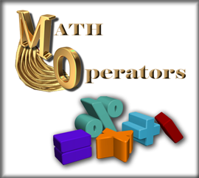

Turn on [Watch SASS](2%20Creating%20the%20Project.docx)

# How to use Math operators in SCSS/ CSS

This is just going to be a rather fast, simple tutorial to introduce you to how we would go about using math operators in calculations in SASS. And the differences of just using regular CSS and how you would do those same calculations.

In regular CSS, you need to wrap your equation in a calc method, but in SASS, we can just do the calculation.

Regular CSS



SASS



When we subtract 55% from the width of our paragraph, it does now look like crap

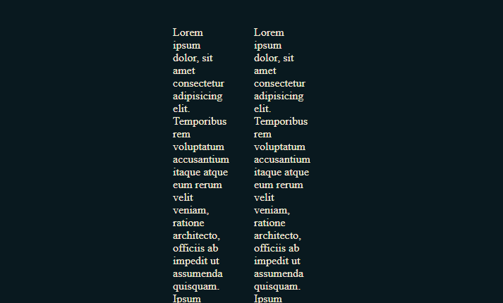

# When you can and cannot mix Operators

In regular CSS we can mix types when we deal with calculations, but in SASS you cannot mix type.

YES, YOU CAN

Regular CSS



Now if you were to remove the calc method and just run it as a Sass calculation, with the mixing of the % sign and the px measure, you will find that the program is no longer listening to you and will just sit at the last measurement style that you wrote correctly.

NO, YOU CAN’T

SASS

